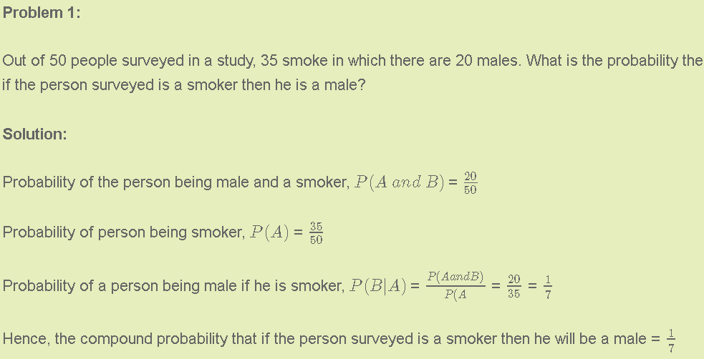

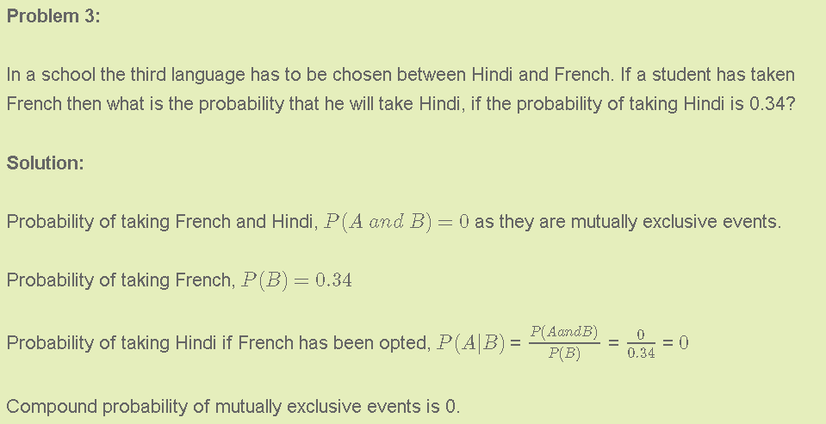

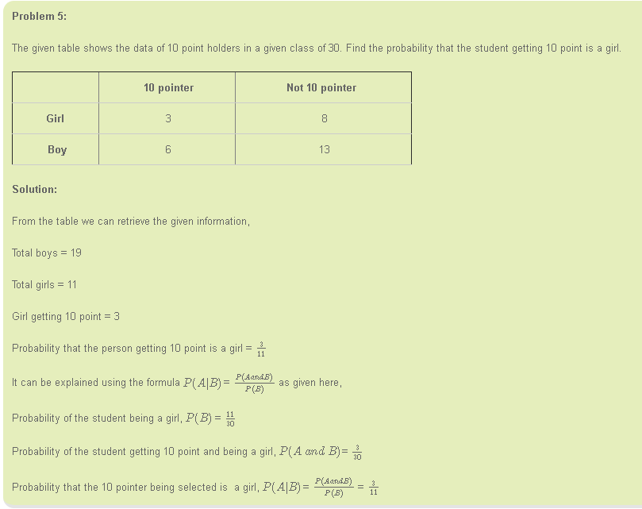

**5.5. Bayes’ Theorem**

Example 1:

*B*: test (positive) *A*: no AIDS

: test (negative) : AIDS

From past experience and records, we know



That is, we know the probability of a patient having no AIDS, the conditional probability of test positive given having no AIDS (wrong diagnosis), and the conditional probability of test positive given having AIDS (correct diagnosis).

Our object is to find , i.e., we want to know the probability of a patient having not AIDS even known that this patient is test positive.

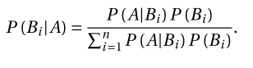

**Independent event**

